Introduction

The Weather App project is a GUI-based Python application that allows users to fetch real-time weather data of any city in the world. It integrates multiple libraries and APIs to deliver a user-friendly experience. Users can search for a city and view current weather information such as temperature, condition, humidity, wind speed, and atmospheric pressure.
This application was developed using Tkinter for the graphical interface, Geopy for geolocation, TimezoneFinder and pytz for time zone information, and the OpenWeatherMap API for weather data.

Code

from tkinter import *
import tkinter as tk
from geopy.geocoders import Nominatim
from tkinter import ttk,messagebox
from timezonefinder import TimezoneFinder
from datetime import datetime
import requests
import pytz
root = Tk()
root.title("Weather App")
root.geometry("900x500+300+200")
root.resizable(False,False)
def getWeather():
city = textfield.get()
geolocator = Nominatim(user_agent="myweatherapp")
try:
location = geolocator.geocode(city)
if location is None:
messagebox.showerror("Error", "City not found!")
return
obj = TimezoneFinder()
result = obj.timezone_at(lng=location.longitude, lat=location.latitude)
home = pytz.timezone(result)
local_time = datetime.now(home)
current_time = local_time.strftime("%I:%M %p")
clock.config(text=current_time)
name.config(text="CURRENT WEATHER")
except Exception as e:
messagebox.showerror("Error", f"Unable to fetch location.\n{e}")
return # Stop execution if geolocation fails
api = f"https://api.openweathermap.org/data/2.5/weather?q={city}&appid=9eb5d61c4f7fdef5aa5cadc89a8971bc&units=metric"
try:
json_data = requests.get(api).json()
# Check if API response contains the expected keys
if "weather" not in json_data or "main" not in json_data:
messagebox.showerror("Error", "Invalid response from weather API")
return
# Extract Weather Data
condition = json_data['weather'][0]['main']
description = json_data['weather'][0]['description']
temp = int(json_data['main']['temp']) # Already in Celsius
pressure = json_data['main']['pressure']
humidity = json_data['main']['humidity']
wind = json_data['wind']['speed']
# Update UI Labels
t.config(text=f"{temp}°C")
c.config(text=f"{condition} | FEELS LIKE {temp}°C")
w.config(text=f"{wind} m/s")
h.config(text=f"{humidity}%")
d.config(text=description.capitalize())
p.config(text=f"{pressure} hPa")
except Exception as e:
messagebox.showerror("Error", f"Weather data fetch failed:\n{e}")
# Search Box
Search_image = PhotoImage(file="search.png")
myimage = Label(image=Search_image)
myimage.place(x=20,y=20)
textfield = tk.Entry(root,justify="center",width=17,font=("poppins",25,"bold"),bg="#404040",border=0,fg="white")
textfield.place(x=50,y=40)
textfield.focus()
Search_icon = PhotoImage(file="search_icon.png")
myimage_icon = Button(image=Search_icon,borderwidth=0,cursor="hand2",bg="#404040",command=getWeather)
myimage_icon.place(x=400,y=34)
# Logo
Logo_image = PhotoImage(file="logo.png")
Logo = Label(image=Logo_image)
Logo.place(x=150,y=100)
# Bottom Box
Frame_image = PhotoImage(file="box.png")
frame_myimage = Label(image=Frame_image)
frame_myimage.pack(padx=5,pady=5,side=BOTTOM)
# time
name = Label(root,font=("arial",15,"bold"))
name.place(x=30,y=100)
clock = Label(root,font=("Helvetica",20))
clock.place(x=30,y=130)
# Label
label1 = Label(root,text="WIND",font=("Helvetica",15,"bold"),fg="white",bg="#1ab5ef")
label1.place(x=120,y=400)

label2 = Label(root,text="HUMIDITY",font=("Helvetica",15,"bold"),fg="white",bg="#1ab5ef")
label2.place(x=250,y=400)
label3 = Label(root,text="DESCRIPTION",font=("Helvetica",15,"bold"),fg="white",bg="#1ab5ef")
label3.place(x=430,y=400)
label4 = Label(root,text="PRESSURE",font=("Helvetica",15,"bold"),fg="white",bg="#1ab5ef")
label4.place(x=650,y=400)
t=Label(font=("arial",70,"bold"),fg="#ee666d")
t.place(x=400,y=150)
c=Label(font=("arial", 15 , 'bold'))
c.place(x=400,y=250)
w=Label(text="...",font=("arial",20,"bold"),bg="#1ab5ef")
w.place(x=120,y=430)
h=Label(text="...",font=("arial",20,"bold"),bg="#1ab5ef")
h.place(x=280,y=430)
d=Label(text="...",font=("arial",20,"bold"),bg="#1ab5ef")
d.place(x=450,y=430)
p=Label(text="...",font=("arial",20,"bold"),bg="#1ab5ef")
p.place(x=670,y=430)
root.mainloop()

RESULT :

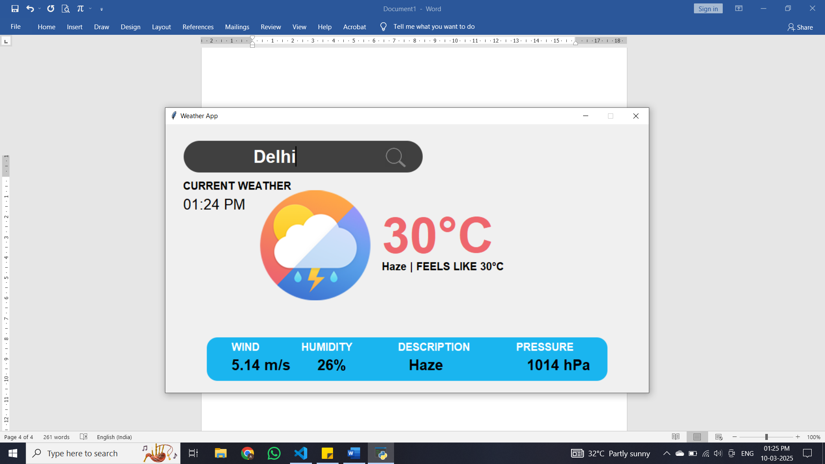

Explanation :
- User Interface with Tkinter:
- A clean and intuitive GUI is created using the Tkinter library.
- Input fields, labels, and buttons are used for interaction.
- Custom icons and images enhance the visual appeal.
- City Input and Geolocation:
- The user inputs the name of a city.
- The Geopy library is used to fetch latitude and longitude using the Nominatim geocoder.
- Timezone and Local Time:
- The latitude and longitude are used to find the city's time zone with TimezoneFinder.
- The datetime and pytz libraries help in displaying the current local time in that city.
- Fetching Weather Data:
- The app sends a request to the OpenWeatherMap API.
- API returns current weather conditions including:
- Temperature
- Weather condition and description
- Wind speed
- Humidity
- Pressure
- Error Handling:
- The application includes robust error handling for scenarios such as:
- Invalid city name
- No internet connection
- API failure or unexpected response
- Data Display:
- All the relevant weather data is displayed on the GUI using labels.
- Real-time data visualization makes the app informative and practical.
- Result Section:
- At the bottom of the application, placeholders (initially showing "...") get updated with weather data once the user performs a search.

